# QUESTION 1

Write an SQL query to calculate the bonus of each employee. The bonus of an employee is 100% of their salary if the ID of the employee is an odd number and the employee’s name does not start with the character 'M'. The bonus of an employee is 0 otherwise.

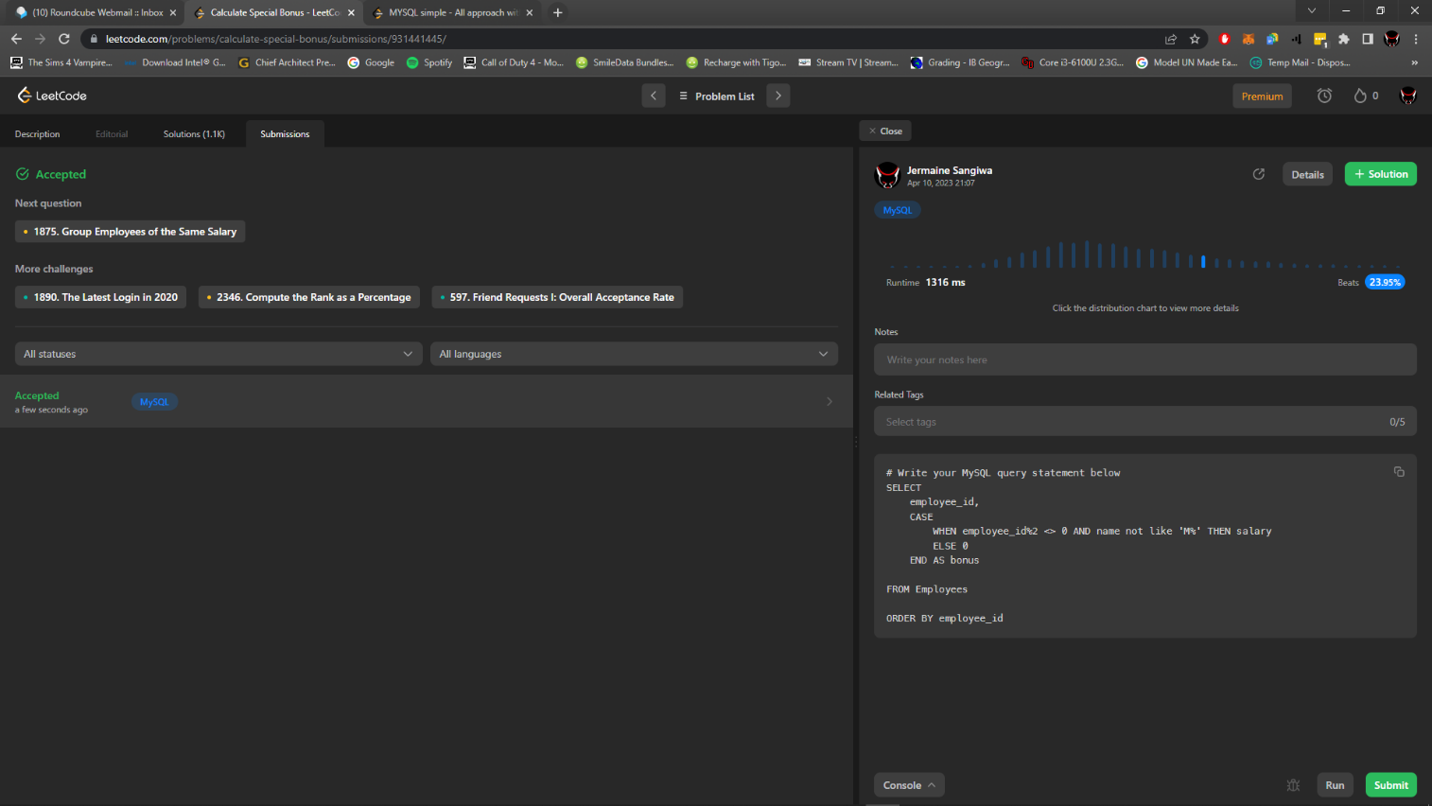Return the result table ordered by “employee_id”.

# QUESTION 2

Write an SQL query to report the IDs of the employees whose salary is strictly less than $30,000 and whose manager left the company. When a manager leaves the company, their information is deleted from the Employees table, but the reports still have their “manager_id” set to the manager that left.

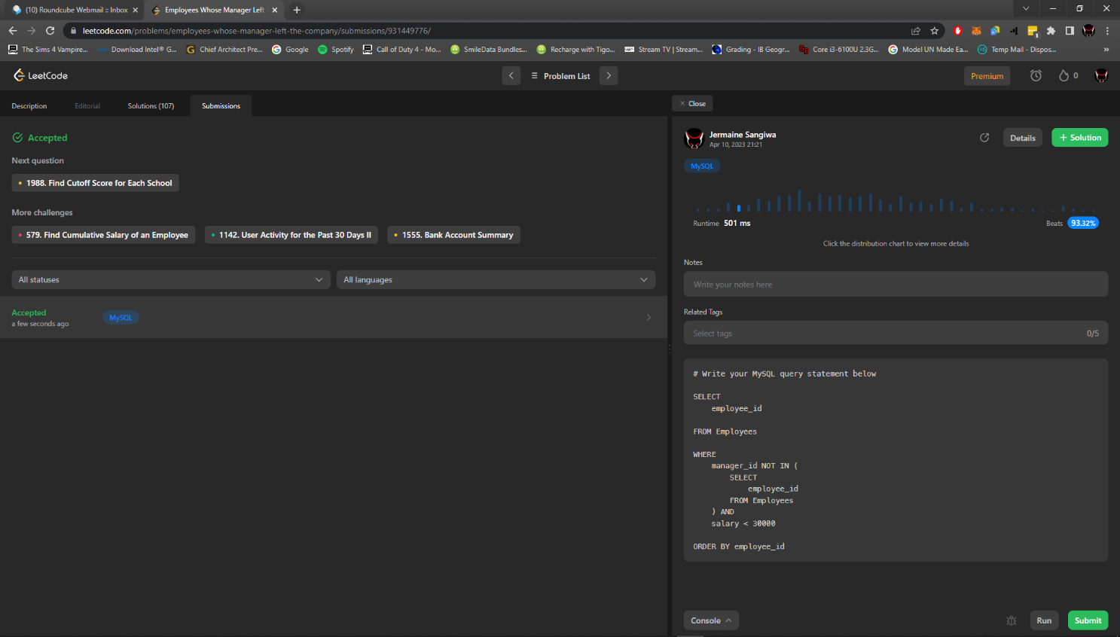Return the result table ordered by “employee_id”.